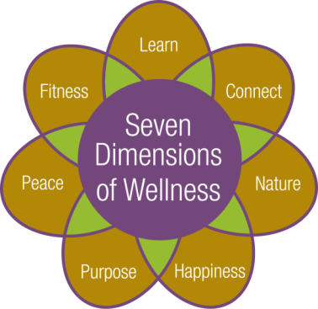



**Cultural and Educational Program Calendar**

**January 2024**





**Cultural Programming Staff**

**Crystal Johnston – Director of Life Enrichment**

Phone: 641-6345

Email: Crystal_johnston@urmc.rochester.edu

Office: Located 2nd floor of Laurelwood

**Elizabeth David – Cultural Programming Coordinator**

Phone: 641-6344

Email: Elizabeth_david@urmc.rochester.edu

Office: Located 2nd floor of Laurelwood

**Use the guides below to help you determine which outings are for you.**

Programs denoted with a wheelchair symbol indicate it is wheelchair accessible.

**Use the asterisk below to help gauge the**

**level of walking an outing requires.**

**\*** Easy Going

**\*\*** On Your Feet

**\*\*\*** Keep the Pace

**\*\*\*\***Let’s Go!



**Monday, January 1st: New Year’s Day**

**No Fitness Classes today, the pool is open you just need a buddy.**

**No Program Planning Meeting today. Next meeting will be held on Monday, January 8th.**

**1:30pm – Crosswords** with Larry Shearer.Laurelwood Gallery

**Tuesday, January 2nd:**

**9:00am – Water Fitness** with Robin Gallagher. Pool

**9:00am, 10:00am, & 11:00am – Depart for shopping and banking** at Country Club Plaza. Please call the Hospitality Desk at 586-7600 to secure transportation.

**10:00am – Perk up Coffee Hour.** Enjoy conversation and a complimentary espresso beveragemade by a Dining Services Team Member. Pub Area

**10:30am-12:00pm – Circuit Training** with Robin Gallagher. Exercise Room

**1:00pm – Knitting Group** with Robin Gallagher. Please bring your own supplies; yarn is available for charity knitting. Music Room

**\*1:00pm – Depart for Eastview Mall, Target and Victor Crossings.** Store selection include Dollar Store, HomeGoods, Kohl’s, Wal-Mart, and PetSmart. **Make holiday returns and enjoy the**

**after-holiday sales!** **Please register on the Registration Calendar located on the Portal.** For questions or registration assistance, contact Elizabeth David at 641-6344. Return approx. 4:00pm

**1:15pm – Bible Study** with Chaplain Steve Petrovich. Laurelwood Gallery

**7:30pm – Lights, Camera, Action - Movie Night!** Join us this month as we feature *TOM HANKS* in your favorite movies.The title will be announced in advance in theDaily Email. Music Room

**Wednesday, January 3rd:**

**9:00am – Fitness Class** with Robin Gallagher. Available in-person & virtually. **The Zoom link will be sent to participants via email the morning of the class.** If you are interested in receiving the Zoom link please contact Robin Gallagher at 641-6316. Hahnemann Club

**10:00am – Tech Time**with the HAP Technology Team. Please bring general inquiries or concerns regarding technology.For questions contact Patrick Langton at 641-6308 or Jeremy Snelgrove at 641-6309. Music Room

**10:15am – Fitness Class** with Robin Gallagher. **In-person only.** Wellness Center

**(Programs for 1/3 continue on next page)**

**1:00pm-2:00pm – Open Swim** with Robin Gallagher. Pool

**\*1:00pm – On Your Own Flower Arranging.** Stop by and make a small floral arrangement.Please bring your own bud vase, the flowers will be provided. **Please register on the Registration Calendar located on the Portal.** For questions or registration assistance, contact Elizabeth David at

641-6344. Laurelwood Activities Room

**No Pittsford Highlands Chorus practice today.**

**2:30pm – Story Time with resident Muriel Herzog**. Join Muriel as she reads aloud to residents. All are welcome. HAP Library

**3:00pm – Line Dancing** with resident Will Herzog.All are welcome. Wellness Center

**4:00pm-6:00pm – Happy Hour:** Enjoy drink specials, appetizers, and great conversation with your neighbors. Community Center

**Thursday, January 4th:**

**9:00am – Water Fitness** with Robin Gallagher. Pool

**9:00am, 10:00am, & 11:00am – Depart for shopping and banking** at Country Club Plaza. Please call the Hospitality Desk at 586-7600 to secure transportation.

**10:00am – Perk up Coffee Hour.** Enjoy conversation and a complimentary espresso beveragemade by a Dining Services Team Member. Pub Area

**10:30am-12:00pm – Circuit Training** with Robin Gallagher. Exercise Room

**11:00am – Gentle Chair Yoga** with Eva Kane. Available in-person & virtually. **The Zoom link will be sent to participants via email the morning of the class.** If you are interested in receiving the Zoom link please contact Robin Gallagher at 641-6316. Wellness Center

**3:30pm – Pet Therapy with Ann Julien and Lulu.** Laurelwood Gallery

**6:30pm – Depart for Regal Eastview for the showing of *The Color Purple.*** **Please note ticket and transportation arrangements were made in advance. For questions please contact Elizabeth David at 641-6344. Return approx. 9:30pm\***



**Friday, January 5th:**

**9:00am – Fitness Class** with Robin Gallagher. Available in-person & virtually. **The Zoom link will be sent to participants via email the morning of the class.** If you are interested in receiving the Zoom link please contact Robin Gallagher at 641-6316. Hahnemann Club

**10:15am – Fitness Class** with Robin Gallagher. **In-person only.** Wellness Center

**1:00pm-2:00pm – Open Swim** with Robin Gallagher. Pool

**1:00pm – First Friday Catholic Mass** with volunteers from St. Louis Church. Music Room

**No Religious Program with Chaplain Steve Petrovich today.**

**2:00pm – Presentation*: Holidays Around the World*** with travel expert Beth Brancato. See page 21 for additional formation. **In-person only.** Community Center

**4:00pm-5:00pm – Friday Social Hour!** Join your neighbors for conversation and light snacks. Community Center

**Saturday, January 6th:**

**10:15am – Fitness: Tai Chi** with Carmen Ramos. **In-person only.** Laurelwood Activities Room

**1:30pm – Weekend Movie Matinee:** The title will be announced in advance in theDaily Email. Music Room

**Sunday, January 7th:**

**9:30am & 10:00am – Depart to local area churches.** Please call the Hospitality Desk at 586-7600 to be added to the transportation list.

**THE BILLS MAKE ME WANNA SHOUT:** Join us for yet another season of watching football. Enjoy light snacks and the love for the Bills as they take on The Miami Dolphins this week! **Please stay tuned as the NFL has not yet released the time for this game.** Community Center

**10:30am – Communion Service** with volunteers from St. Louis Church. Music Room

**11:00am – Asbury First United Methodist Church Live Stream Service.** Laurelwood Activities Room

**1:30pm – Weekend Movie Matinee:** The title will be announced in advance in theDaily Email. Music Room



**Monday, January 8th:**

**9:00am – Fitness Class** with Robin Gallagher. Available in-person & virtually. **The Zoom link will be sent to participants via email the morning of the class.** If you are interested in receiving the Zoom link please contact Robin Gallagher at 641-6316. Hahnemann Club

**10:15am – Fitness Class** with Robin Gallagher. **In-person only.** Wellness Center

**11:00am – Program Planning Meeting.** All are welcome to discuss, evaluate, and suggest outings and lectures. Music Room

**1:00pm-2:00pm – Open Swim** with Robin Gallagher. Pool

**2:00pm – Presentation: *Why a Revolution***with Rochester Historian Dan Cody. Please see page 21 for more information. Available in-person & virtually. **The Zoom link will be sent to all residents via the Daily Email the morning of the presentation.** Community Center

**Tuesday, January 9th:**

**9:00am – Water Fitness** with Robin Gallagher. Pool

**No shopping and banking** **today. Enjoy a trip to Tops Friendly Markets. See below for departure time.**

**10:00am – Perk Up Coffee Hour.** Enjoy conversation and a complimentary espresso beveragemade by a Dining Services Team Member. Pub Area

**10:00am – Depart for shopping at Tops Friendly Markets.** Please call the Hospitality Desk at 586-7600 to secure transportation.

**10:30am-12:00pm – Circuit Training** with Robin Gallagher. Exercise Room

**12:50pm – First Presbyterian Church Small Group Fellowship and Prayer.** All are welcome.

2nd Floor Activities Room

**1:15pm – Bible Study** with Chaplain Steve Petrovich. Laurelwood Gallery

**2:00pm – UR Always Learning 4-week Lecture Series: *What is the Field of Music and Medicine?*** with Gaelen McCormick, Director, Eastman Performing Arts Medicine at the University of Rochester.Please see page 19 for weekly topics. **In-person only**. To register please email the events line at [HighlandsEvents@URMC.rochester.edu](mailto:HighlandsEvents@URMC.rochester.edu) or call 641-6303. **In-person only.** Community Center

**6:30pm – Evening Entertainment** with Bangers & Mash Jazz Quartet, **featuring Dan Atkinson, 19-year-old sophomore at the Eastman School of Music.** Community Center

**7:30pm – Lights, Camera, Action - Movie Night!** Join us this month as we feature *TOM HANKS* in your favorite movies.The title will be announced in advance in theDaily Email. Music Room

**Wednesday, January 10th:**

**9:00am – Fitness Class** with Robin Gallagher. Available in-person & virtually. **The Zoom link will be sent to participants via email the morning of the class.** If you are interested in receiving the Zoom link please contact Robin Gallagher at 641-6316. Hahnemann Club

**10:00am – Tech Time: *Amazon Returns!*** with the HAP Technology Team. For questions contact Patrick Langton at 641-6308 or Jeremy Snelgrove at 641-6309. Music Room

**10:15am – Fitness Class** with Robin Gallagher. **In-person only.** Wellness Center

**1:00pm-2:00pm – Open Swim** with Robin Gallagher. Pool

**1:00pm – Caregivers Support Group** with facilitator Connie Craig, MSW and a Certified Aging Life Specialist (Care Manager). All are welcome. **Reminder this group is only meeting once a month now.** 2nd Floor Activities Room

**1:30pm – Pittsford Highlands Chorus practice.** All are welcome to participate. New members always welcome! Music Room

**2:30pm – Story Time with resident Muriel Herzog**. Join Muriel as she reads aloud to residents. All are welcome. HAP Library

**3:00pm – Line Dancing** with resident Will Herzog.All are welcome. Wellness Center

**4:00pm-6:00pm – Happy Hour.** Enjoy drink specials, appetizers, and great conversation with your neighbors. Community Center

******\*4:15pm – Depart for dinner at Charlie Browns in Penfield, NY.** Dinner will be paid for on your own. **Please register on the Registration Calendar located on the Portal.** For questions or registration assistance, contact Elizabeth David at 641-6344. Return Approx. 7:00pm**\***

**Thursday, January 11th:**

**9:00am – Water Fitness** with Robin Gallagher. Pool

**9:00am, 10:00am, & 11:00am – Depart for shopping and banking** at Country Club Plaza. Please call the Hospitality Desk at 586-7600 to secure transportation.

**10:00am – Perk up Coffee Hour.** Enjoy conversation and a complimentary espresso beveragemade by a Dining Services Team Member. Pub Area

**10:30am-12:00pm – Circuit Training** with Robin Gallagher. Exercise Room

**(Programs for 1/11 continue on next page)**

**11:00am – Gentle Chair Yoga** with Eva Kane. Available in-person & virtually. **The Zoom link will be sent to participants via email the morning of the class.** If you are interested in receiving the Zoom link please contact Robin Gallagher at 641-6316. Wellness Center

**\*1:00pm – Shopping in Henrietta**. Shops include Bed Bath & Beyond, DSW, Dress Barn and Talbots Outlet Enjoy grabbing some of those after holiday deals! **Please register on the Registration Calendar located on the Portal.** For questions or registration assistance, contact Elizabeth David at 641-6344. Return approx. 4:00pm **\*\*\***

**3:30pm – Pet Therapy with Ann Julien and Lulu.** Laurelwood Gallery

**6:30pm – Depart for the Rochester Philharmonic Orchestra Concert*:*** ***The Rite of Spring Featuring Garth Fagan Dance!*****Please note transportation and ticket arrangements were made in advance, but there still may be some tickets available.** Contact the RPO Patron Services Center at 454-2100 if you are interested in obtaining a ticket. Contact Elizabeth David at 641-6344 with questions or to secure transportation. Return approx.10:00pm**\*\***

**Friday, January 12th:**

**9:00am – Fitness Class** with Robin Gallagher. Available in-person & virtually. **The Zoom link will be sent to participants via email the morning of the class.** If you are interested in receiving the Zoom link please contact Robin Gallagher at 641-6316. Hahnemann Club

**1:00pm-2:00pm – Open Swim** with Robin Gallagher. Pool

**1:15pm – Poems, Quotes, & Songs** with Chaplain Steve Petrovich.Laurelwood Gallery

**2:30pm – Afternoon Entertainment: Bagpipes with Jake** - An Afternoon of Music, History, and Celtic Culture. See page 21 for additional information. Community Center

**4:00pm-5:00pm – Friday Social Hour!** Join your neighbors for conversation and light snacks. Community Center

**Saturday, January 13th:**

**10:15am – Fitness: Tai Chi** with Carmen Ramos. **In-person only.** Laurelwood Activities Room

**1:30pm – Weekend Movie Matinee:** The title will be announced in advance in theDaily Email. Community Center

**3:30pm – Enjoy a Pet Therapy visit from RocDog,** a Non-Profit Therapy Dog Organization that prepares

dogs and handlers for visitations. Laurelwood Gallery

**Sunday, January 14th:**

**9:30am & 10:00am – Depart to local area churches.** Please call the Hospitality Desk at 586-7600 to be added to the transportation list.

**10:30am – Communion Service** with volunteers from St. Louis Church. Community Center

**11:00am – Asbury First United Methodist Church Live Stream Service.** Laurelwood Activities Room

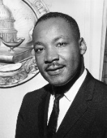**1:30pm – Weekend Movie Matinee:** The title will be announced in advance in theDaily Email. Music Room

**Monday, January 15th: Martin Luther King Jr. Day**

**No Fitness Classes with Robin Gallagher today.Pool is open you jut need a buddy.**

**11:00am – Monthly Documentary: *Unknown: The Lost Pyramid.*** In the sands of Saqqara, two of the world's most famous Egyptologists, Dr. Zahi Hawass and his protege and rival, Dr. Mostafa Waziri race with their teams against the clock to see who will make the biggest discovery. Community Center

**1:00pm – Go Green Group**. This group researches and discusses practices that may lead to more environmentally-friendly and ecologically-responsible lifestyles at HAP.All are welcome. Music Room

**1:30pm – Presentation: *Music & Life of Kate Smith***with Larry Shearer. Laurelwood Activities Room

**No Flower City Jazz Society Concert­­ this evening. They will reconvene in February.**

**Tuesday, January 16th:**

**9:00am – Water Fitness** with Robin Gallagher. Pool

**9:00am, 10:00am, & 11:00am – Depart for shopping and banking** at Country Club Plaza. Please call the Hospitality Desk at 586-7600 to secure transportation.

**10:00am – Perk up Coffee Hour.** Enjoy conversation and a complimentary espresso beveragemade by a Dining Services Team Member. Pub Area

**10:30am-12:00pm – Circuit Training** with Robin Gallagher. Exercise Room

**\*11:30am – Depart for the Tuesday Pipes Concert at Christ Church. Please Register on the Registration Calendar located on the portal.** No fee to attend. For questions or registration assistance, contact Elizabeth David at 641-6344.Return approx. 1:30pm**\***

**12:50pm – First Presbyterian Church Small Group Fellowship and Prayer.** All are welcome.

2nd Floor Activities Room

**(Programs for 1/16 continue on next page)**

**1:15pm – Bible Study** with Chaplain Steve Petrovich. Laurelwood Gallery

**2:00pm – UR Always Learning 4-part Lecture Series: *Music for Self-Care and Wellness*** with Rosie Obi, LCAT. MT-BC, Manager of Music Therapy at the Golisano Children’s Hospital. Please see page 19 for weekly topics. **In-Person only.** To register please email the events line at [HighlandsEvents@URMC.rochester.edu](mailto:HighlandsEvents@URMC.rochester.edu) or call 641-6303. **In-person only.** Community Center

**7:30pm – Lights, Camera, Action - Movie Night!** Join us this month as we feature *TOM HANKS* in your favorite movies.The title will be announced in advance in theDaily Email. Music Room

**Wednesday, January 17th:**

**9:00am – Fitness Class** with Robin Gallagher. Available in-person & virtually. **The Zoom link will be sent to participants via email the morning of the class.** If you are interested in receiving the Zoom link please contact Robin Gallagher at 641-6316. Hahnemann Club

**10:00am – Tech Time: *Streaming Services (Apple TV, Netflix, Disney + w/Hulu).*** For questions contact Patrick Langton at 641-6308 or Jeremy Snelgrove at 641-6309. Music Room

**\*10:00am – Depart for the Strasenburgh Planetarium for another private viewing of *Black Holes Revealed;* followed by lunch at Rome Café.** **(This outing is back by popular demand.)** Show is approx. 45 min. Admission fee is $12.00 and will be collected on the bus. Lunch will be paid for on your own. **Please register on the Registration Calendar located on the Portal.** See page 20 for additional show information. For questions or registration assistance, contact Elizabeth David at 641-6344. Return approx. 1:45pm**\***

**10:15am – Fitness Class** with Robin Gallagher. **In-person only.** Wellness Center

**1:00pm-2:00pm – Open Swim** with Robin Gallagher. Pool

**1:30pm – Pittsford Highlands Chorus practice.** All are welcome to participate. New members always welcome! Music Room

**2:30pm – Story Time with resident Muriel Herzog**. Join Muriel as she reads aloud to residents. All are welcome. HAP Library

**3:00pm – Line Dancing** with resident Will Herzog.All are welcome. Wellness Center

**4:00pm-6:00pm – Happy Hour:** Enjoy drink specials, appetizers, and great conversation with your neighbors. Community Center



**Thursday, January 18th:**

**9:00am – Water Fitness** with Robin Gallagher. Pool

**9:00am, 10:00am, & 11:00am – Depart for shopping and banking** at Country Club Plaza. Please call the Hospitality Desk at 586-7600 to secure transportation.

**10:00am – Perk up Coffee Hour.** Enjoy conversation and a complimentary espresso beveragemade by a Dining Services Team Member. Pub Area

**10:30am-12:00pm – Circuit Training** with Robin Gallagher. Exercise Room

**11:00am – Gentle Chair Yoga** with Eva Kane. Available in-person & virtually. **The Zoom link will be sent to participants via email the morning of the class.** If you are interested in receiving the Zoom link please contact Robin Gallagher at 641-6316. Wellness Center

**\*11:30am – Eastman at Washington Square Concert: *Winter Double Bill-Strauss and Purcell*** featuring two great works in the operatic cannon. No fee to attend. **Please register on the Registration Calendar located on the Portal.** For questions or registration assistance, contact Elizabeth David at 641-6344. Return approx. 1:30pm**\***

**\*1:30pm – New Year’s BINGO!** Come enjoy a fun game of BINGO with your friends. Great prizes will be given to winners! **Please register on the Registration Calendar located on the Portal.** For questions or registration assistance, contact Elizabeth David at 641-6344. Community Center

**3:30pm – Pet Therapy with Ann Julian and Lulu.** Laurelwood Gallery

**6:30pm – Evening Entertainment:** Piano Recital with students taught by Rachel Michaels. Community Center

**Friday, January 19th:**

**9:00am – Fitness Class** with Robin Gallagher. Available in-person & virtually. **The Zoom link will be sent to participants via email the morning of the class.** If you are interested in receiving the Zoom link please contact Robin Gallagher at 641-6316. Hahnemann Club

**10:15am – Fitness Class** with Robin Gallagher. **In-person only.** Wellness Center

**\*11:00am – Depart for lunch at Philips European.** Enjoy a bountiful menu along with decadent desserts. Lunch will be paid for on your own. **Please register on the Registration Calendar located on the Portal.** For questions or registration assistance, contact Elizabeth David at 641-6344. Return approx. 2:00pm**\***



**(Programs for 1/19 continue on next page)**

**1:00pm-2:00pm – Open Swim** with Robin Gallagher. Pool

**1:15pm – Poems, Quotes, & Songs** with Chaplain Steve Petrovich. Laurelwood Gallery

**2:30pm – Afternoon Entertainment:** Enjoy jazz music played on the piano by Dr. Beata Golec. Community Center

**4:00pm-5:00pm – Friday Social Hour!** Join your neighbors for conversation and light snacks. Community Center

**Saturday, January 20th:**

**10:15am – Fitness: Tai Chi** with Carmen Ramos. **In-person only.** Laurelwood Activities Room

**1:30pm – Weekend Movie Matinee:** The title will be announced in advance in theDaily Email.

Music Room

**Sunday, January 21st:**

**9:30am & 10:00am – Depart to local area churches.** Please call the Hospitality Desk at 586-7600 to be added to the transportation list.

**10:30am – St. Louis Church Live Stream Communion Service**.A volunteer from the parish will be at The Highlands to give communion. All are welcome. Music Room

**11:00am – Asbury First United Methodist Church live stream service.** Laurelwood Activities Room

**1:30pm – Weekend Movie Matinee:** The title will be announced in advance in theDaily Email. Music Room

**Monday, January 22nd:**

**9:00am – Fitness Class** with Robin Gallagher. Available in-person & virtually. **The Zoom link will be sent to participants via email the morning of the class.** If you are interested in receiving the Zoom link please contact Robin Gallagher at 641-6316. Hahnemann Club

**10:00am – Book Discussion Group, Book Title: *The Book of Hope*** by Jane Goodall. **Please note the permanent room change location.**Music Room

**10:15am – Fitness Class** with Robin Gallagher. **In-person only.** Wellness Center

**1:00pm-2:00pm – Open Swim** with Robin Gallagher. Pool

**2:00pm – Presentation: *EquuStrong, Inc.***with President & FounderJonathan Friedlander. Learn about the opportunities for experiential learning through equestrian and nature-based activities at the incredibly beautiful 100-acre Oak Ridge Farm in Mendon, New York. **In-person only.** Community Center

**Tuesday, January 23rd:**

**9:00am – Water Fitness** with Robin Gallagher. Pool

**9:00am, 10:00am, & 11:00am – Depart for shopping and banking** at Country Club Plaza. Please call the Hospitality Desk at 586-7600 to secure transportation.

**10:00am – Perk Up Coffee Hour.** Enjoy conversation and a complimentary espresso beveragemade by a Dining Services Team Member. Pub Area

**10:30am-12:00pm – Circuit Training** with Robin Gallagher. Exercise Room

**12:50pm – First Presbyterian Church Small Group Fellowship and Prayer.** All are welcome.

2nd Floor Activities Room

**1:15pm – Hymn Study** with Chaplain Steve Petrovich. Laurelwood Gallery

**2:00pm – UR Always Learning 4-part Lecture Series: *Music Therapy and Physical, Social, and Mental Health:  How They Connect and Why That Matters*** with Molly Pow, MS, LCAT, MT-BC; Music Therapist at Strong Memorial Hospital. See page 20 for weekly topics. To register please email the events line at [HighlandsEvents@URMC.rochester.edu](mailto:HighlandsEvents@URMC.rochester.edu) or call 641-6303. **In-person only.** Community Center

**7:30pm – Lights, Camera, Action - Movie Night!** Join us this month as we feature *TOM HANKS* in your favorite movies.The title will be announced in advance in theDaily Email. Music Room

**Wednesday, January 24th:**

**9:00am – Fitness Class** with Robin Gallagher. Available in-person & virtually. **The Zoom link will be sent to participants via email the morning of the class.** If you are interested in receiving the Zoom link please contact Robin Gallagher at 641-6316. Hahnemann Club

**10:00am – Tech Time**with the HAP Technology Team. Please bring general inquiries or concerns regarding technology.For questions contact Patrick Langton at 641-6308 or Jeremy Snelgrove at 641-6309. Music Room

**10:15am – Fitness Class** with Robin Gallagher. **In-person only.** Wellness Center

**1:00pm-2:00pm – Open Swim** with Robin Gallagher. Pool

**1:30pm – Pittsford Highlands Chorus practice.** All are welcome to participate. New members always welcome! Music Room

**2:00pm – Presentation:** ***The Legacy of Lillian Wald* with** Patricia Corcoran from the Friends of Mt. Hope Cemetery. See page 21 for additional information. **In-person only.** Community Center

**(Programs for 1/24 continue on next page)**

**2:30pm – Story Time with resident Muriel Herzog**. Join Muriel as she reads aloud to residents. All are welcome. HAP Library

**3:00pm – Line Dancing** with resident Will Herzog.All are welcome. Wellness Center

**4:00pm-6:00pm – Happy Hour:** Enjoy drink specials, appetizers and great conversation with your neighbors. Community Center

**Thursday, January 25th:**

**9:00am – Water Fitness** with Robin Gallagher. Pool

**9:00am, 10:00am, & 11:00am – Depart for shopping and banking** at Country Club Plaza. Please call the Hospitality Desk at 586-7600 to secure transportation.

**10:00am – Perk up Coffee Hour.** Enjoy conversation and a complimentary espresso beveragemade by a Dining Services Team Member. Pub Area

**10:30am-12:00pm – Circuit Training** with Robin Gallagher. Exercise Room

**11:00am – Gentle Chair Yoga** with Eva Kane. Available in-person & virtually. **The Zoom link will be sent to participants via email the morning of the class.** If you are interested in receiving the Zoom link please contact Robin Gallagher at 641-6316. Wellness Center

**\*2:00pm – Depart for Moonlight Creamery in Fairport, NY.** Moonlight offers fair trade and certified products that promote environmental sustainability. Menu includes ice cream, coffee, tea, and artisan chocolates. **Please register on the Registration Calendar located on the Portal.** For questions or registration assistance, contact Elizabeth David at 641-6344. Return approx. 3:45pm**\***

**3:30pm – Pet Therapy with Ann Julien and Lulu.** Laurelwood Gallery

**6:30pm – Depart for the Rochester Philharmonic Orchestra Concert*: The Planets: HD Odyssey Featuring 35 Years of NASA Footage****.* **Please note transportation and ticket arrangements were made in advance, but there still may be some tickets available.** Contact the RPO Patron Services Center at 454-2100 if you are interested in obtaining a ticket. Contact Elizabeth David at 641-6344 with questions or to secure transportation. Return approx.10:00pm**\*\***



**Friday, January 26th:**

**9:00am – Fitness Class** with Robin Gallagher. Available in-person & virtually. **The Zoom link will be sent to participants via email the morning of the class.** If you are interested in receiving the Zoom link please contact Robin Gallagher at 641-6316. Hahnemann Club

**\*9:30am – Depart for lunch and shopping at Sauders Market.** A taste of Mennonite Culture located in Seneca Falls, NY. No fee to attend. **Please register on the Registration Calendar located on the Portal.** For questions or registration assistance, contact Elizabeth David at 641-6344. Return approx. 1:15pm**\*\***

**10:15am – Fitness Class** with Robin Gallagher. **In-person only.** Wellness Center

**1:00pm-2:00pm – Open Swim** with Robin Gallagher. Pool

**1:15pm – Name That Tune** with Chaplain Steve Petrovich. Laurelwood Gallery

**4:00pm-5:00pm – Friday Social Hour!** Join your neighbors for conversation and light snacks. Community Center

**Saturday, January 27th:**

**10:15am – Fitness: Tai Chi** with Carmen Ramos. **In-person only.** Laurelwood Activities Room

**1:30pm – Weekend Movie Matinee:** The title will be announced in advance in theDaily Email. Music Room

**3:30pm – Enjoy a Pet Therapy visit from RocDog,** a Non-Profit Therapy Dog Organization that prepares

dogs and handlers for visitations. Laurelwood Gallery

**Sunday, January 28th:**

**9:30am & 10:00am – Depart to local area churches.** Please call the Hospitality Desk at 586-7600 to be added to the transportation list.

**10:30am – Communion Service** with volunteers from St. Louis Church. Community Center

**11:00am – Asbury First United Methodist Church live stream service.** Laurelwood Activities Room

**1:30pm – Weekend Movie Matinee:** The title will be announced in advance in theDaily Email. Music Room

**Monday, January 29th:**

**9:00am – Fitness Class** with Robin Gallagher. Available in-person & virtually. **The Zoom link will be sent to participants via email the morning of the class.** If you are interested in receiving the Zoom link please contact Robin Gallagher at 641-6316. Hahnemann Club

**10:15am – Fitness Class** with Robin Gallagher. **In-person only.** Wellness Center

**\*12:00pm-1:30pm – Pizza Party Luncheon. Residents only.** **Please register on the Registration Calendar located on the Portal.** **Please note space is limited.** No fee to attend. For questions or registration assistance, contact Elizabeth David at 641-6344. Oneida Dining Room

**1:00pm-2:00pm – Open Swim** with Robin Gallagher. Pool

**2:30pm – Resident Meeting.** In-person and virtual. **The Zoom link will be sent to all residents via the Daily Email the morning of the meeting. Community Center**

**Tuesday, January 30th:**

**9:00am – Water Fitness** with Robin Gallagher. Pool

**9:00am, 10:00am, & 11:00am – Depart for shopping and banking** at Country Club Plaza. Please call the Hospitality Desk at 586-7600 to secure transportation.

**10:00am – Perk Up Coffee Hour.** Enjoy conversation and a complimentary espresso beveragemade by a Dining Services Team Member. Pub Area

**10:30am-12:00pm – Circuit Training** with Robin Gallagher. Exercise Room

**\*11:30am – Depart for the Tuesday Pipes Concert at Christ Church. Please Register on the Registration Calendar located on the portal.** No fee to attend. For questions or registration assistance, contact Elizabeth David at 641-6344.Return approx. 1:30pm**\***

**12:50pm – First Presbyterian Church Small Group Fellowship and Prayer.** All are welcome.

2nd Floor Activities Room

**1:15pm – Bible Study** with Chaplain Steve Petrovich. Laurelwood Gallery

**2:00pm – Virtual** **Presentation: *Exploring the Dark Universe with the Euclid*** with Valerie Rapson, Ph.D., Assistant Professor at SUNY Oneonta. See page 22 for additional information. **The Zoom link will be sent to all residents via the Daily Email the morning of the presentation.** This virtual presentation is also available to view in the Community Center.

**7:30pm – Lights, Camera, Action - Movie Night!** Join us this month as we feature *TOM HANKS* in your favorite movies.The title will be announced in advance in theDaily Email. Music Room

**Wednesday, January 31st:**

**9:00am – Fitness Class** with Robin Gallagher. Available in-person & virtually. **The Zoom link will be sent to participants via email the morning of the class.** If you are interested in receiving the Zoom link please contact Robin Gallagher at 641-6316. Hahnemann Club

**10:00am – Tech Time**with the HAP Technology Team. Please bring general inquiries or concerns regarding technology.For questions contact Patrick Langton at 641-6308 or Jeremy Snelgrove at 641-6309. Music Room

**10:15am – Fitness Class** with Robin Gallagher. **In-person only.** Wellness Center

**1:00pm-2:00pm – Open Swim** with Robin Gallagher. Pool

**1:30pm – Pittsford Highlands Chorus practice.** All are welcome to participate. Please contact Elizabeth David at 641-6344 with questions. New members always welcome! Music Room

**2:00pm – UR Always Learning 4-part Lecture Series: *Mindfulness in Music Therapy*** with Leigh Kirby, MS, MT-BC, Music Therapist at the Pluta Cancer Center. See page 20 for weekly topics. To register please email the events line at [HighlandsEvents@URMC.rochester.edu](mailto:HighlandsEvents@URMC.rochester.edu) or call 641-6303. **In-person only.** Community Center

**3:00pm – Line Dancing** with resident Will Herzog.All are welcome. For more information, please contact Will at 381-7368. Wellness Center

**4:00pm-6:00pm – Meet, Mix, and Mingle Happy Hour for Newcomers:** Enjoy drink specials and appetizers and great conversation with your neighbors. Community Center

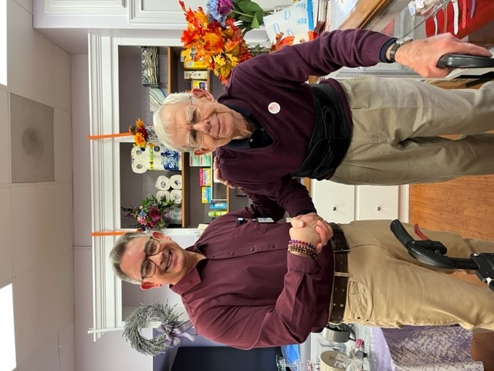

Staff member Tom from the Lilac Shoppe

with resident Peter Dillon.

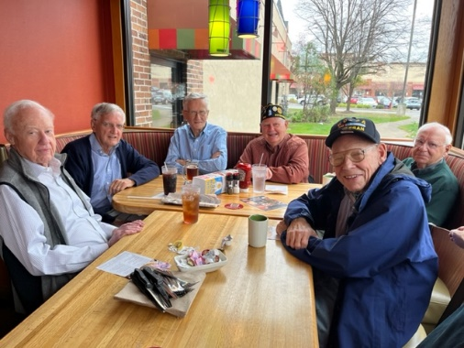2023 Memories!

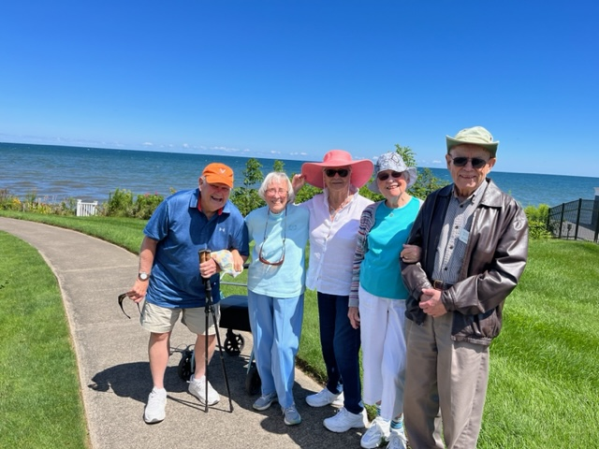

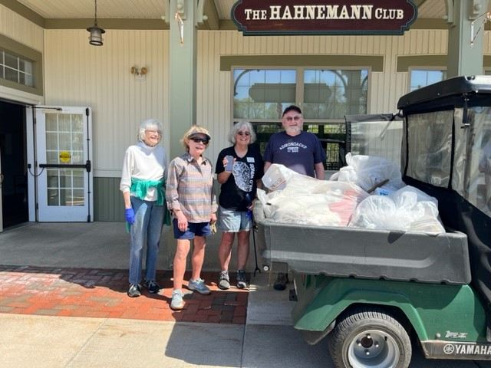

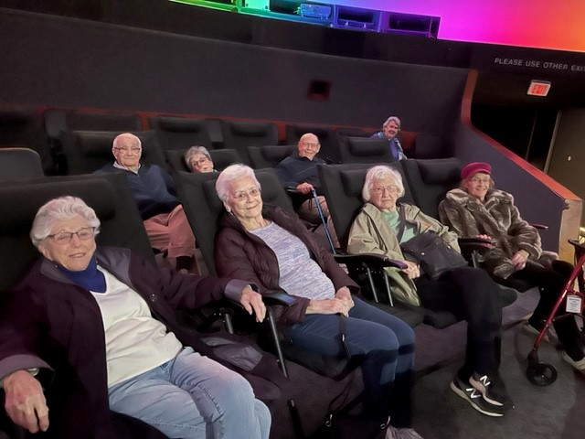

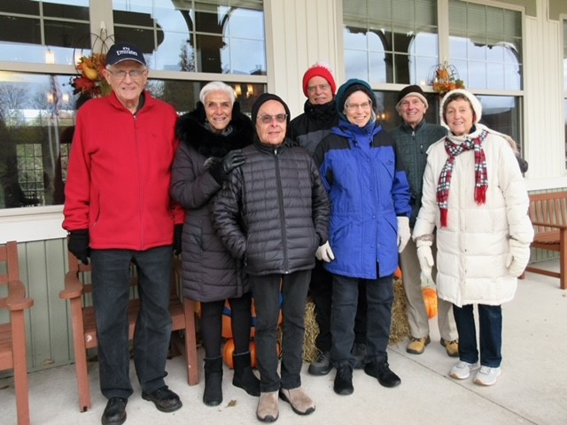

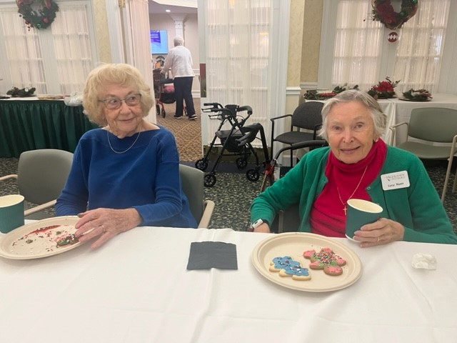

**University of Rochester Lectures**

**Tuesday, January 9th at 2:00pm**

**What is the field of Music and Medicine?**

Many of us use music to help motivate a workout or to self-soothe, and we are aware of the connection we have to music as a tool for support. But what are the ways that music is showing up in the healthcare environment? This presentation will showcase the many roles that music can play in supporting the health and wellbeing of the hospital community.

**Bio:**

**Gaelen McCormick** is the Director of Eastman Performing Arts Medicine (EPAM) at the University of Rochester and has joint faculty appointments at the Eastman School of Music and the Department of Health Humanities and Bioethics in the School of Medicine and Dentistry. Before joining EPAM in 2018, she was a musician with the Rochester Philharmonic Orchestra from 1995-2017. Leading EPAM has allowed Gaelen to focus on artist wellness and the use of music and arts in the healthcare setting. She has successfully obtained grants for performance opportunities and pilot programs implementing live music in healthcare spaces, most recently from the National Endowment for the Arts. Gaelen holds degrees in music performance from the Eastman School of Music and Carnegie Mellon University.

**Tuesday, January 16th at 2:00pm**

**Music for Self-Care and Wellness**

This presentation will provide opportunities for participants to explore how to incorporate music into their self-care and wellness journey.  Participants will have the opportunity to engage in music-based self-care experiences and group discussion.

**Bio:**

**Rosemary Obi** is a Licensed Creative Arts Therapist and Board-Certified Music Therapist with over 20 years of experience working in the medical setting. Rosemary is a Senior Music Therapist at the University of Rochester Medical Center, where she manages the Music Therapy Program at Strong Memorial Hospital and Golisano Children’s Hospital.  She also provides individual and group music therapy sessions to pediatric patients with a variety of chronic and acute diagnoses. She is passionate about the role of creative arts therapy in healthcare and eager to expand these services throughout UR Medicine. Rosemary received her Bachelor of Music in Music Therapy from the University of Dayton and her Masters in Creative Arts Therapy from Nazareth College.

**Tuesday, January 23rd at 2:00pm**

**Music Therapy and Physical, Social, and Mental Health:  How They Connect and Why That Matters**

The biopsychosocial model (BPS) is a philosophy of clinical care that weaves the individuals' biological, social, and psychological lived experiences which contribute in equal parts, to their overall physical and mental health.  This presentation will provide opportunities for the participants to discuss BPS health, learn how music therapy services directly impact BPS health, and experience examples of music therapy clinical intervention.

**Bio:**

**Molly Pow, MS, LCAT, MT-BC**, is a New York State Licensed Creative Arts Therapist and national Board-Certified Music Therapist.   Molly has provided individual and group music therapy services throughout Arizona and New York state to individuals across the lifespan for 15 years. Specializing in mental health and wellness, neurologic conditions, and trauma care, Molly presently works with adult patients and their personal supporters within Physical Medicine and Rehabilitation and Critical Care units at the University of Rochester's Strong Memorial Hospital.

**Wednesday, January 31st at 2:00pm**

**Mindfulness in Music Therapy**

This presentation will provide an overview of the presence of mindfulness in music therapy, and the health benefits of being aware and connected to ourselves/others in the moment. Participants will have the opportunity to engage in music listening and music-making.

**Bio:**

**Leigh A Kirby, MS MT-BC** is a board-certified music therapist who has over 15 years of experience in the field providing direct services, teaching, researching, and founding a non-profit. She is currently a music therapist for Pluta Integrative Oncology & Wellness Center and Western New York Comprehensive Care Center for Eating Disorders. She performs from time to time and is also a piano teacher. Leigh harnesses the therapeutic power of music to ground and center us, help us process our situation, manage symptoms, create coping skills, and embrace wellness. She loves the creative arts and believes that there are endless possibilities when music is involved!

**Outings**

**Wednesday, January 17th at 10:00am**

**Strasenburgh Planetarium: Black Holes Revealed**

In a black hole, gravity triumphs over all other forces, bringing space and time to an end. Black holes are almost unbelievable, but multiple clues now tell us they are real. To find out about these bizarre objects, we’ll fly to the center of the Milky Way, out to a dying star, and back to the early universe. Take a comfortable seat under our Planetarium dome for a simulated journey near a black hole. Projected on the Star Theater dome, this show is programmed with our best current knowledge of black holes.

**Lectur****es/ Entertainment**

**Friday, January 5th at 2:00pm**

**Holidays Around the World**

What is the history of our beloved Christmas and New Year’s traditions...The Christmas tree, stockings, Santa? Why is Hanukkah so important in the Jewish culture?  And what other holidays are celebrated around the world that bring joy and hope?!

**Monday, January 8th at 2:00pm**

**Why a Revolution**

Our Founding Fathers just didn’t wake up on July 4, 1776, and decide to seek independence from Great Britain. It was the accumulation of years of events which brought the colonists to such a drastic and treasonous decision. Learn about what led up to that fateful decision.

**Friday, January 12th at 2:30pm**

**Bagpipes with Jake**

Join professional bagpiper Jake Kwiatkowski for a showcase of this powerful and unique instrument. Jake will be playing different styles of bagpipe music, telling the history of the instrument - spoiler, the bagpipes aren't originally from Scotland... - and offering personal stories from his decades as a bagpiper. There will be great highland bagpipes - the loud ones - and Scottish "Fireside pipes" - much quieter ones - played at this event.

**Wednesday, January 24th at 2:00pm**

**The Legacy of Lillian Wald**

The story of Lillian Wald describes a life of activism, dedication, and accomplishment. She was a nurse, teacher, social worker, author, suffragist, child advocate, trade unionist and immigrant rights leader—in every aspect of her life, she was a pioneer.

Lillian founded the Visiting Nurse Service of New York and the Henry Street Settlement in New York City. She considered Rochester her home and is buried with her family in Mount Hope Cemetery.

She was a prolific writer, and her words hold special significance in today’s world. You will be inspired by a woman recognized during her life as one of the greatest living women of her time.

**Bio:**

**Patricia Corcoran** is a graduate of Le Moyne College and earned a master’s degree from SUNY Brockport. After teaching two years in Corning, she went to Turkey in the Peace Corps and taught English in a public school for gifted children.

After leaving Turkey, Pat arrived in Rochester and began her 30-year career as an ESOL teacher in the Rochester City School District.

Following her retirement, Pat was the acting director of the graduate TESOL program at Nazareth College and an adjunct instructor at SUNY Geneseo, St. John Fisher College, and Nazareth College.

She is the immediate past president of the Friends of Mount Hope Cemetery. She has been fascinated by the story of Lillian Wald for many years and is excited to share the life of this incredible woman with the residents of the Highlands.

**Tuesday, January 30th at 2:00pm**

**Exploring the Dark Universe with the Euclid**

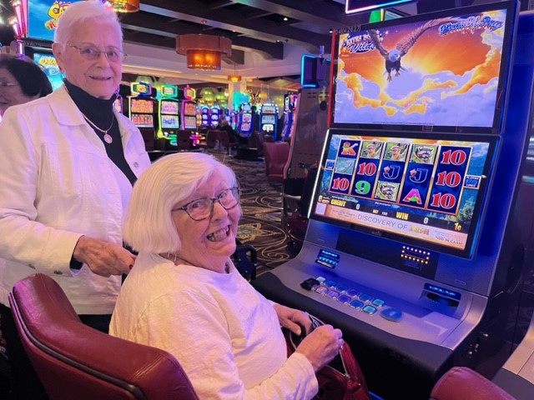Dark matter and dark energy have baffled astronomers since their discovery. The collapse of dark matter seems to have caused the growth of galaxies in the early Universe, while dark energy is responsible for the expansion of the Universe. The recently launched Euclid mission aims to tie these two things together and explore how the Universe has expanded and changed over time. In this talk I’ll reveal some of Euclid’s first images, and discuss how this telescope plans to shine more light on these mysterious dark phenomena.

2023 Overnight at del Lago Resort and Casino!

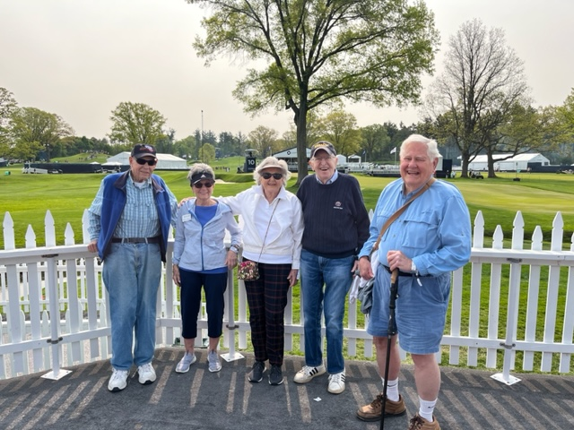

2023 LPGA at Oak Hill Country Club

**Resident Committees and Discussion Groups**

Residents are invited to play an active role in The Highlands community through involvement in various committees and discussion groups. If you find a committee or group that may be of interest to you (see below), we encourage you to reach out to the designated contact person to learn more about the group’s purpose and how to join.

**Book Discussion Group** Resident, Nancy Hare Apt. 113

Phone: (585) 586-4769

Email: nwhare3@gmail.com

**Community Outreach Committee** Maria Sommerville, Director of Sales & Marketing

Phone: (585) 641-6381

Email: Maria_Sommerville@urmc.rochester.edu

**Dining Committee** Andy Trepanier, Director of Dining Services

Phone: (585) 641-6334

Email: andy_trepanier@urmc.rochester.edu

**Friendship Committee** Maria Sommerville, Director of Sales & Marketing

Phone: (585) 641-6381

Email: Maria_Sommerville@urmc.rochester.edu

**Go Green Group** Resident, Ralph Carter, Cottage 202

Phone: (585) 267-7247

Email: rcarter56@gmail.com

Resident, Mary Lynn Vickers, Apartment 224

Phone: (585) 485-0010

Email: mvicker1@rochester.rr.com

**Landscape Committee** Russell Perrone, Director of Facilities

Phone: (585) 641-6302

Email: russell_perrone@urmc.rochester.edu

**Library Committee** Crystal Johnston, Director of Life Enrichment

Phone: (585) 641-6345

Email: [crystal_johnston@urmc.rochester.edu](mailto:crystal_johnston@urmc.rochester.edu)

**Line Dancing** Resident Will Herzog, Apt. 249

Phone: 381-7368

Email: track2@frontiernet.net

**Pittsford Highlands Chorus** Elizabeth David, Cultural Program Coordinator

**Program Planning Meeting**  Phone: (585) 641-6344

**Support Group** Email: [elizabeth_david@urmc.rochester.edu](mailto:elizabeth_david@urmc.rochester.edu)